**Test Plan for a Company management system**

Test Plan Id Company_01_system

Project Name Company Management system

Prepared By QA Lead

Date 30-09-2025

Objective Ensure that Login module,company module,user

module,services,categories, appointments,bill product and all its reports worked properly with validation,without any kind of glitch and loading issue. The product should provide the best quality as much possible it can Provide .It should handle load without crashing itself and the product remain constant in resources as much possible as

Scope The testing should focus on the Login of the user,companies creating the

companies,User,User roles,Categories,Service,Service Packages,Customers,Appointments,Bills,Products,Sell Products, all this module should be work Smoothly

Outscope There is no reports in the system about any of the pages so the reports

pages are not going to be tested,There is not any inventory module which will track the stock of the Customer. For now the module will not provide the full and consistent data about any of the services so the accuracy and integrity will not taken seriously,There is also the not mentioned about the feedback module for their customers to rate their service

Reference Software Product Itself  
 Software Modules and sub module

Software Flow diagram

Test Strategy

In the testing strategy we will use the waterfall model for simple approach Because the application is already half done, in that type of condition the strategy should be simple to sync with the development process

Entry Criteria:

-The Software’s Basic flow should be working properly with Proper validation without any blocker issue

-The Product should be uploaded and set in the testing environment for the testing process

-The Dummy company is created for testing the product

-The Dummy roles for different company is created to test the application Position wise

-The Dummy Services and Service Packages Are created with the customer to test the flow if a customer choose a service or a services packages so how the product will behave

-The Product Which are Sold Report (Dummy Report) are Made to test the stock outward report through Software

On Hold Criteria -If the system have any critical Blocker issue which will interrupt or block

the Forward testing flow of the application then it will remain in Hold state

-If the testing environment like hardware and software are unavailable in between the software testing then the testing will in hold mode

-If the Resources are unavailable in between the process of the testing process (E.g Tester,Tools,System Resources,Particular devices)

-If there is a Critical bug which will interrupt test flow then the testing will remain in hold state until it properly slove

On Resume Criteria -If the critical blocker solved then the testing process will start from

where it stopped

-If the testing environment will comes to a stable condition then testing will back to its normal process

-After the availability of the resources for the testing then the testing will come back it action with quick process

Exit Criteria -All the Test cases and the requirements are fully covered

-If the testing have not any kind of critical or major issue then the testing

Can be exit it’s process

-If the product work fine as it’s requirement then the testing will exit it’s process

-After the Testing Bug reports,Test closer report,Test case report and Test Coverage report submitted to QA Lead/Product Manager

Functional Testing **1.Login Page**

**-**This module should be allow the user to login to the system when the user enter the correct username and correct password

-If the User enter the wrong credentials then the module should display the error message and don’t allow the user to login to the system

-Bruit force and other hacking related methods should not work here and if tried multiple times then the user should be blocked by the system

-The forget password section should work correctly in the situation of user forget his/her login password

**2.Dashboard**

**-**This module should be displayed after the successful login of the user

-This Module Should be display All the Services which the product have as per the requirement

-All the mentioned modules should be accessible from the dashboard without any additional credentials

**3.Company**

-This module should only accessible to the super admin of the software to make companies for their clients

-This module should work properly without any mistake and error and the company details should be protected from attackers

-The company details should be only visible to the super admin and owner of the company and the details should edited by the super admin only not the owner of the company it self

-Name of the company,Contact number ,Official Mail,logo, This type of data should be displayed to the customers,employees of the company.

**4.User**

-This module should be visible only to the admin and the super admin also to create the user for the company. Creating And allowing the user user to their permission according to their position wise in company by the admin

-The customize,view,and edit option should work properly without any issue to update,view and delete the user rights or users from that company

-The rights should be remain constants while or after creating the user and according to the rights the user should allowed to do it’s allowed work in the application

**5.User Roles**

-This module is the specifically role based rights module where all the predefined roles are defined with their necessary rights by the owner

-The predefine rights should allowed to that matching criteria of the user and automatically rights should be allowed to that user

-The Predefined rights should only be edited by the admin and the access of this page only to the admin

-This page should be secure from their client,employee and the hacker to prevent full access and data breach.

**6.Services**

-This module’s data should be displayed to the client,employee and admin To showcase their facility provided by their company to their customer

-The module will help the customers to choose their services with their acknowledgement how much the service cost and how much of time will be taken if they buy the service

-This services should be remain constant to the user until it updated by the admin and employee of the company

-The view,edit and delete option should work properly for the future updation and deletion by the owner or employee who have rights to do that

**7.Service Packages**

-This module will showcase the combo packages and some combo package offer to their customer for better customer services

-The company should be allowed to make as much service packages as they want to make the service package they want

-The same view,delete and edit option should be there to future upgradation of the service packages to the owner or employee who have rights to do that

**8.Customer**

-This customer module should display the status of the customer to the company for evaluation and make better decisions for their company.

-This module should show how many of the customers are newly connected with the company.

-This module should also have that feature to that how many of the customer are connected by the referral of other existed customer

-There should be a history page to the specific customer so that the company can evaluate which customer is often taking their services so that they can give better facilities or offers to their customer.

**9.Appointments**

-This module is too crucial for the company to provide the better facility to their customer and provide the

-This module is will display the future appointments of the customer to use their services at a particular time

-The module will provide which customer wants the service at which particular date and when did the customer apply for that service.

-The status of that service will be updated by the assigned employee of the company.

-The appointment module will display that also which customer will attend which customer at which particular time so the proper and fine services would be provided to the customer

-Due to the predefined scheduling of the service to the customer services,it is beneficial to the customer and employee both.

**10.Bills**

-This module should record all money transaction which are successfully done or which are ordered only

-This module should only accessible to the owner and the financial employee who have the rights of this page

-Delete and update of a transaction record can be allowed only to the owner only

-The Excel report Generation option should be there for better evaluation for the company

-This Module will display the bill unique number,customer name,amount ,status should be display there

-Through the view option there should be a details view of the customer transaction should be displayed properly with GST and all Types of included taxes

**11.Products**

-This module will display the product list of the company which is selling by the company

-This module have the functionality of add product manually,download CSV file,Download excel file, this functionality work properly without any error

-The product filter should work properly (like the dropdown should have the predefined option should be there for the better filter out products from the list of products)

**12.Sell Products**

-First of all the module name should be sold product or reports for better understanding

-This module should display the all types the product sold reports to which customer in which invoice

-Module have that functionality which will display the order list and completed order by the company

**UI Components Testing** -All the components should be properly aligned in with the system

Boundary

-The UI components should be remain constant before and after any kind of the action in the system

-The Grammar should correct in the place of of content page and other pages where there are some information about the company

Non-Functional testing **Performance**

-The system should be loaded in just 3 seconds with accurate data

-The system should be quick responsive and fetch the data from the server in below 10 seconds

-The system should be able to handle 3000 thousand logins at a time With efficiency

-The system Should be in same resource availability from start of login to finish

**Reliability**

-The system should fetch the correct and accurate data when it requested for it

-The system data should be matched with the actual data of the customer,employee,admin,financial transaction ,product data

-

**Availability**

-The system should available all time without any issue the customer,employee,owner can use this product without any timebound

-The product should allow the customer to book his/her slot after the shop or company time

-The employee should be able to see their next day schedule after the company time also without any issue

**Security**

**-**The Customer data should be protected from data breaches,hacker, and any kind fraudsters

-The deleted employee should not be able not access the system

-The financial transaction should be only visible to the owner and the allowed financial transaction employee

-The customer should not be able to view other customers details,transaction history it should be protected from them

-After more than 3 wrong login attempts the username should be blocked for the specific time

**Maintainability**

-The software should be maintainable as quick as possible when there is a issue occur in the system

-The yearly maintain of the product should be easily done without any other issue

Test environment

Operating System: Windows 11 (64-bit) with 8GB RAM  
Browsers: Google Chrome v141.0.7943.5, Safari v17.0.3  
Network: Stable broadband connection (100 Mbps)  
Devices: Mobile, Tablet, and Desktop  
Mobile OS: Supports iOS 15,Android 13 and above  
Configured IP: 192.168.4.56  
Access: All systems connected via internal LAN under the above IP range

Tools:Selenium WebDriver, Postman, JMeter, TestNG

Deliverables Test documents

Test Cases

Bug Report

Test Closer report

Defect management life cycle In the defect management life cycle we will use the simple

Defect management lifecycle flow which will help the entire team to

follow easily

We will use the following flow for the defect management

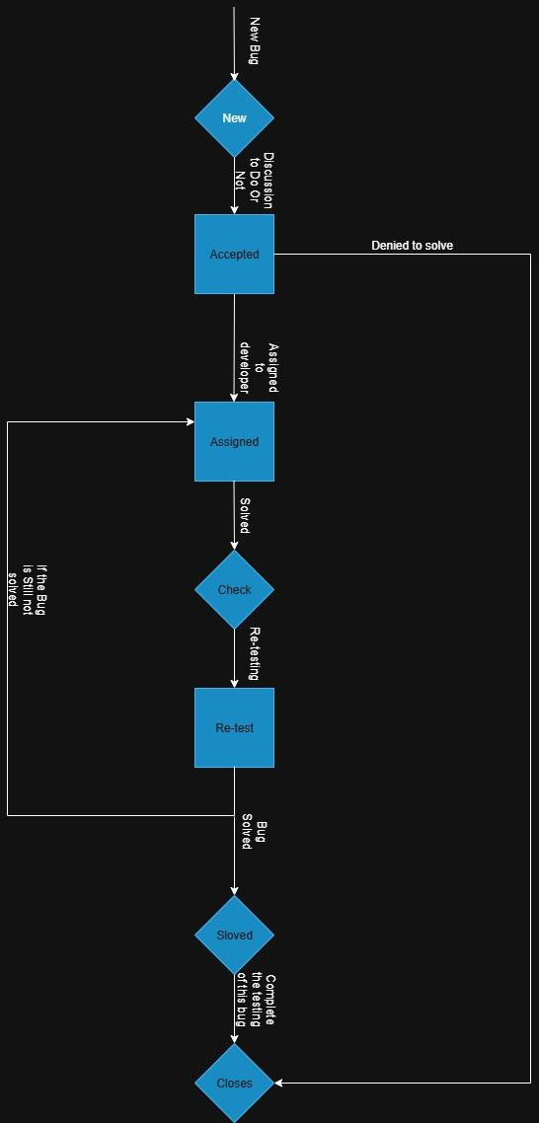

Roles &

Responsibilities QA Team: They will verify the Product's functionality,security,Restrictions

Roles,Logins the possible test cases,verify the Match with the requirement and try to deliver the product with quality

QA Lead/Manager:They will manage the resources for the testing process so that the testing will be done without any interruption and they will verify the documentation of product related like SRS document,DFD document,Data flow Diagram,Test cases documentation ,Bug reports,Test coverage reports,Test closer reports

Developers:They will solve the reported bug given by the tester and develop the new feature as per the client's requirements and make changes with as much possible as evolution

Test Schedule

| Test Schedule | From date | To Date | Approval by | Designation |
| --- | --- | --- | --- | --- |
| Requirement understanding | 10-10-2025 | 16-09-2025 | Ravi Nahak | Document head |
| Test Case designing | 17-10-2025 | 26-10-2025 | Dhruv Patel | QA Lead |
| Test case execution | 27-10-2025 | 04-10-2025 | Hiren Patel | QA Manager |
| Re-Test the Uploaded Bug | 05-10-2025 | 14-10-2025 | Deeepak Nahak | Supervisor |
| Test Closer report | 15-10-2025 | 19-10-2025 | Ketan Parab | Product Manager |

Risk and Mitigation Risk:This system can’t generate the accurate reports of the sold products,services so the client can analysis the growth and loss of the company

Mitigation:As per now the system can’t generate the accurate and quality reports but the development is on the way so the the report related functionality will be released in next released

Risk:As per now the system can’t display the growth and loss in Graph dynamically so the client can’t see the company’s daily growth and loss

Mitigation:As per now it also will recover in next upcoming release

Risk:There is not any facility for the customers of the company where they will raise complaint,give feedback,read new articles about the company etc. the customer can’t get the daily update and response against their complaint it will affect the company’s reputation

Mitigation:The module will be developed in future as per now the customer will have to manage the complaint by their own through the phone calls or messages

Approval

| Name of person | Date of approve | Designation |
| --- | --- | --- |
| Hiren Patel | 02-09-2025 | QA Manager |
| Dhruv Patel | 02-09-2025 | QA Lead |
| Ketan Parab | 03-09-2025 | Product Manager |